Bus Ticketing System Solution

# High Level Architecture Diagram:

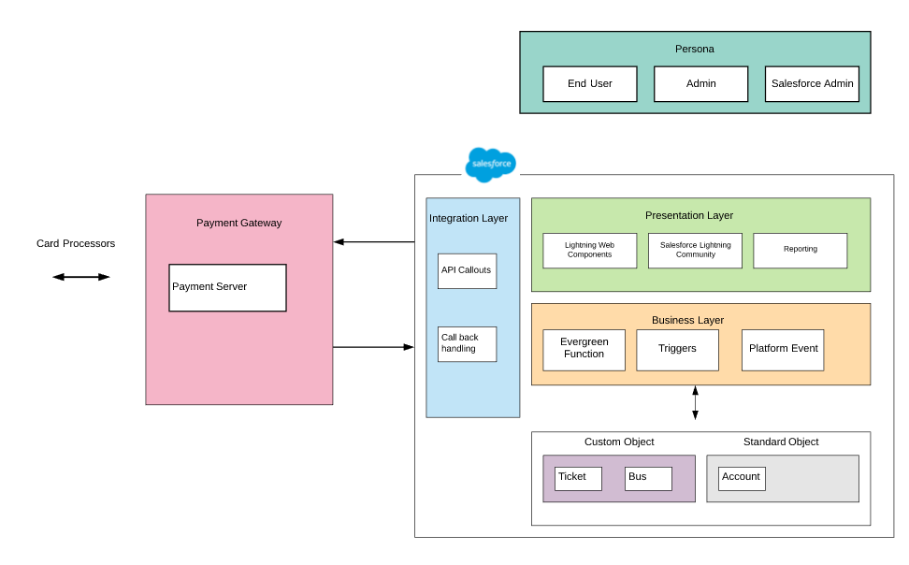

Description:

Persona:

* End User : User who uses the mobile app to book tickets
* Admin: User responsible for creating, cancelling bus trips
* Salesforce Admin : User responsible for configuring and managing the application. This would be a system admin

Salesforce Architecture:

Presentation Layer: We would be using the following salesforce tools/ technologies

1. Lightning Web Components : This is used to build custom UI on the salesforce platform
2. Salesforce Lightning Communities : This is mostly used to expose application outside of the organization. We will be using this to enable the end user to book tickets.
3. Reporting: Standard salesforce feature used for reporting. Can be used for various purposes like tickets sold in a month etc..

Business Layer:

* Evergreen function : Latest offering from salesforce to overcome salesforce limits.
* Triggers: Everytime a bus trip is cancelled, we can use triggers for further processing
* Platform Event : We will be using this to call the evergreen function

Integration Layer:

For payment purposes we will need to integrate the salesforce system with third party applications. This can either be salesforce packages like chargent available on appexchange or will need api integration with third party.

Database model:

We will be utilizing both custom objects and standard objects for this system.

# Database Model:

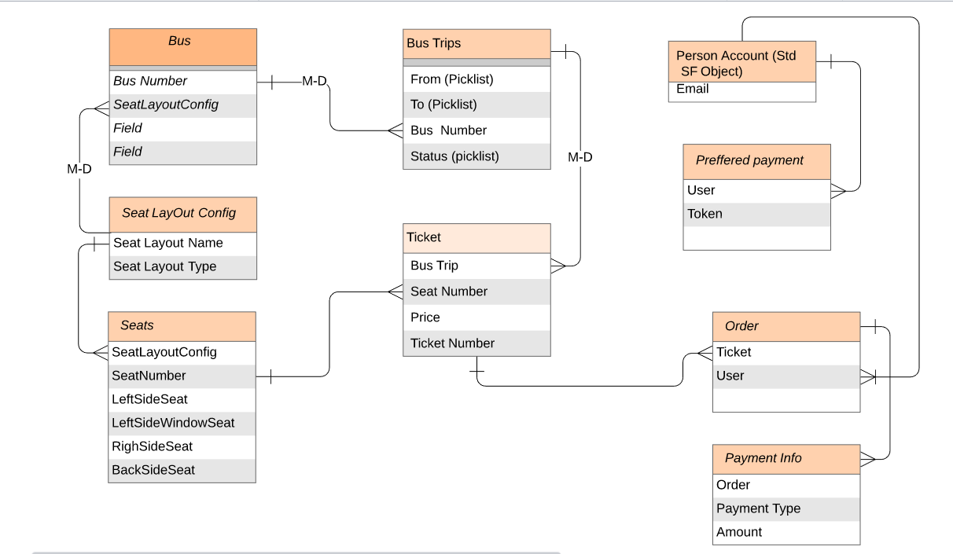

Custom Object:

**Bus** : This object will store information related to bus like bus number.

Important fields :

* SeatLayoutConfig: To associate seat layout with the bus

**Seat Layout Config**: Used for having genric seat layout for buses. For eg: 40 seater buses may have the same layout. The same layout can be used by different buses. We would be creating different records based on their layouts, it can be 60 seaters, 40 seaters etc..

**Seats** : Seats would be child of Seat Layout Config. Various fields here would be used to denote the location on the layout like left window seat. There can be a mechanism to auto generate these records everytime a seat layout config record is created based on number of seats.

**Bus trip**: Stores the trips with to and from cities. This object will also store the timings. Status field here will be used to cancel the trips. Status would have values Ready and Cancelled.

**Tickets**: Everytime a bus trip is created with Ready Status, tickets would be auto created via a trigger on bus trip object. This would be associated to each seat in the seat layout. The prices can be either manual or if needed some automation can be done.

**Order**: Sold ticket information will be stored in order object

**Payment Info** : This will store the amount and the payment type(Credit card, debit card)

Standard object:

**Account** : We will be using person accounts to store the end user information.

Creat SelfRegistered - Set this field to true on person account on self registration

# Solution Approach:

1. Use salesforce customer community for end users to search and book tickets
2. Utilize salesforce feature to allow users to self register.
3. Use person account to store end users information.
4. Customize to identify person accounts created via self registration.

## Stories and solution approach:

1. **As an end-user, I should be able to book tickets between 2 cities from a mobile app**

* **First we will need to create community on salesforce. Salesforce can be contacted to create a branded app from this community which can be published on play store and app store**
* We will have to provide search functionality for the user to be able to search buses between different cities.
* This can be accomplished by using Lightning web components and Apex.
* busSearch(LWC) - Lightning Web component with picklist options to select To and From cities. These To and From picklists would be fetched from Bus Trip object

Once both the picklists have values, we can call apex functions to fetch values from Bus Trip object.

* busSearchTable(LWC): The search table showing buses along with start timings and ticket price with Book tickets button. These components can be configured to display on a lightning app page using lightning builder

1. **As an end-user, I should be able to select the seat and pay for the ticket**

* Once the user clicks on book ticket button, a model will be opened to show the bus seat layout.

busSeatLayout(LWC) : Query tickets records associated with the bus trip.

These seats will be iterated to be displayed on the screen. Screen will be divided into 4 columns. Group the seats by their location. Left side window seats, left side seats, right side seats,right side window seats.

Tickets which are sold will be indicated on the UI

Payment(LWC): On click of the payment button, we can display the payment component. Based on the user who is booking the ticket, fetch the preferred payment option from preferred payment option object. This will also contain the uneditable amount.Apex for this component will be used to integrate with the 3rd party payment gateway.On Successful payment, show success message and navigate user

1. **As an admin, I should be able to create bus trips and see the list of customers:**

* Create a separate profile for 'Bus Trip Admin' with Salesforce Platform License
* Give Read,Write, Create access to Bus Trip object.
* Create criteria based sharing setting rule on person object, share these with the 'Bus Trip admin'.

1. **As an admin, I should be able to cancel any bus trip.**

* Status field on bus trip object will have values Ready, Cancelled.
* On setting the status as cancelled fire the platform event 'Notify__e' using procecss builder/trigger. This event will be handled by the evergreen function.
* Create a custom notification in salesforce. This can be used to show notifications in mobile as well as desktop.
* Separate profile ‘Bus Trip Admin’ with read,write access on bus trip to be used.

**Profiles**:

* System Administrator for salesforce admin
* Bus Community Profile for end users
* Bus Trip Admin for admin

**Salesforce Licenses:**

* Salesforce for Salesforce Admin
* Customer Community for end users
* Salesforce Platform for Admin